# **PRD: Go4Local**

## **Vision**

For working professionals and senior citizens who want to buy groceries but do not have time to go out, our new product Go4Local helps connect them with local grocery store owners. Unlike Big Basket, we deliver products from local brands freshly delivered at a lower cost.

**Motivation**

**Customer Segments**

This platform connects has two major customer segments which are the buyers and the sellers. There are sub-segments for each of these two categories.

* 1. Buyers

The top three buyer segments we identified are working professionals, students, and senior citizens. Working professionals are our main target, they do not have time to go to the stores due to their hectic work schedule and wish to order groceries in advance. Senior citizens are our second major target buyers, because they do not have help at home, stay independent away from their family and have health concerns. Lastly, there are students living by themselves in rented houses, they cannot afford help and usually stay away from family for their education. We validated the assumption that there is an unmet need for these segments by interviewing customers from Mumbai. We found that people in this segment generally call the store and send the list to get products delivered by their cashiers. The service was often delayed along with unclear bills. People from this segment also often could not find time for shopping generally when needed products from multiple stores. The buyer's customer segments are detailed below.

|  |  |
| --- | --- |
| Title | Working professionals |
| Age | 25 - 40 |
| Income level | >$14000/ year (10,00,00 INR) |
| Location | Mumbai, Maharashtra, India |

|  |  |
| --- | --- |
| Title | Senior Citizens |
| Age | 60+ years |
| Income level | >$7000/ year (5,00,000 INR) |
| Location | Mumbai, Maharashtra, India |

|  |  |
| --- | --- |
| Title | Students |
| Age | 18-25 |
| Budget | > 2,500$ / year (2,00,000 INR) |
| Region | Mumbai, Maharashtra, India |

* 1. Sellers

Our main target sellers are grocery store owners who sell essential groceries. We then also include pharmacists and dairy product store owners. These are the small businesses most often found in every small area in the city of Mumbai. The target segment was further narrowed based on annual revenue. This helped us align with our larger vision of uplifting local small businesses. We tested our hypothesis by interviewing people from these segments in Mumbai. We found that they desire to reach out to more customers in their neighborhood as they have seen many people order online but their business’ infrastructure does not allow them to scale up.

|  |  |
| --- | --- |
| Title | Grocery Shops owners |
| Distance proximity | < 2 Kilometers |
| Revenue (Annual) | < 140,000 $ (1,00,00,000 INR) |
| Region | Mumbai, Maharashtra, India |

|  |  |
| --- | --- |
| Title | Pharmacists |
| Distance proximity | < 2 Kilometers |
| Revenue (Annual) | < 80,000 $ (60,000 INR) |
| Region | Mumbai, Maharashtra, India |

|  |  |
| --- | --- |
| Title | Dairy Product Store owners |
| Distance proximity | < 2 Kilometers |
| Revenue (Annual) | < 250,000 $ (1,80,00,000 INR) |
| Region | Mumbai, Maharashtra, India |

Early adopters of our products will be those we have some relationship with. The buyers could be our friends & family, along with people in our neighborhood. Since there is a higher chance of these buyers using our platform, the shops in the neighborhood could become our early adopters for seller segments. There is high trust due to close relationships, the referral system to expand could work well initially. The early adopters would prioritize cash-on-delivery over advance payment, compared to the mainstream users. In addition to that, early adopters would seek the word of mouth to decide on using the service, whereas advertisements would work better for mainstream users.

**Customer Persona**

1. **Buyer**

1. Graphical user interface

   Description automatically generated**Seller**

**Unmet Needs**

1. Working Professional: I believe working professionals face the problem of finding time to buy groceries due to their ever-changing and hectic schedules. They get tired and feel unwilling to go out to shop. Their only option is purchasing from franchise stores which sell at a higher cost and lack the quality the customers are familiar with in their local stores. Rajath, a working professional says, “I feel big brand products are more expensive than the ones that we get at our local stores. But I can find only big stores on delivery apps, not the local ones.”
2. Senior Citizen: I believe senior citizens living alone face the challenge of bringing groceries to their homes and of buying multiple products from different shops because they are physically weak. Their only option is to call the shop and ask them to deliver by sending their employees. Meenakshi, a senior citizen says, “Sometimes I am not well, and other times I am caught with other things. In those times I call up my son, who is living 5 miles away, or maid to help me out in getting stuff from stores. Otherwise, I will call the store owner and if there is no rush in the store, he will send his boy to deliver things and charge for the delivery.”
3. Student: I believe students living independently away from home have difficulty managing time to buy groceries due to their hectic academic and social schedules. They also experience unclear pricing structure when shopping in new cities for products without MRP example - dairy products, grains, etc due to this they end up spending more. Sakshi, a student says, “Order from Big Basket which has 2hr delivery time until 10 pm night, but I can choose only from their product. Desired brands not available like for products - sugar, paneer, only inhouse brands available.”
4. Grocery store owner: I believe grocery store owners experience a shortage of staff and time when delivering the products to the daily customers. This reduces the profits and is also a bad experience for the target users. Due to the large market and competition, they also lose some customers. Guruprasad, a local grocery store owner says, “I usually do not offer home delivery of products unless they are placing a large order and if they are regular customers at my shop. I would not charge extra.”
5. Dairy store owner: I believe dairy store owners are very high in demand throughout the day and experience a high number of customers in the shop daily. Hence, there is no time for the owner to send a person away from the shop for delivery. Existing daily milk delivery costs them high and inconvenience due to lack of vehicle, no delivery charge, on-time delivery to more than 1000+ customers, and at the same time avoiding milk spillage/ product damage. Ramesh, a dairy store owner says, “We usually have a milk delivery service twice a day in local buildings. For milk, we do not have a minimum order amount and do not have any delivery service for other dairy products like cheese, yogurt, cakes, bread, etc. The shop is crowded and it’s impossible to take orders.”
6. Pharmaceutical store owner: I believe local pharmaceutical store owners do not deliver medicines because of high delivery costs and low shopping cart prices. Arjun, a pharmacy owner says, “Minimum order is Rs 400. Sometimes people call up just to deliver Crocin or Paracetamol, and it is not feasible, hence this amount.”

### Existing Solutions

**Current existing solutions include the following:**

1. As and when a person requires or feels the need to go and get a product or a commodity from his nearby local store, he ventures out by physically himself/herself to procure it. It can be a common household grocery item or a medicine (along with his prescription).
2. They can use an already existing smartphone-based application to place an order to get the item delivered by paying a fee for the service.
3. Some local grocery store owners provide the service of delivering groceries and items to the doorstep if the order exceeds a certain amount, through which the customer calls up the local grocery store owner to place an order and get it delivered.

All the existing solutions mentioned above require the customer to physically go and get it by himself or to use an already existing application to place an order delivery.

The existing solutions cannot meet the customer’s needs as it makes it hard for a certain subset of customers to physically step out to get the items and groceries which they require frequently. Senior citizens or working professionals find it hard to get the groceries and medicines by themselves. In addition, the online delivery applications do not let the customer get their order delivered within a stipulated amount of time. At times they have to schedule an order which will be delivered the next day causing inconvenience when the customer requires medicines during an emergency. Applications such as Big Basket deliver products only sold by them. One of our customers, Nandini, who is a senior citizen, said that she often could not find her favorite products and the fruits & vegetables delivered were of poor quality.

Grocery store owners who are willing to provide this service expect the customer to place a minimum order which is at times a large value which refrains the customer to request the order and in addition, they do not provide the service of live tracking which frustrates the customer and requires the customers to make repeated calls to the grocery store owner/local pharmacy to get status updates on his order. One of our customers, Hariprasad, who owns a grocery store, said that more people want their products delivered home. He said, since he doesn’t have the infrastructure for this, they find it hard to deliver on time.

## **Verbal/Visual Walkthrough of Use Cases**

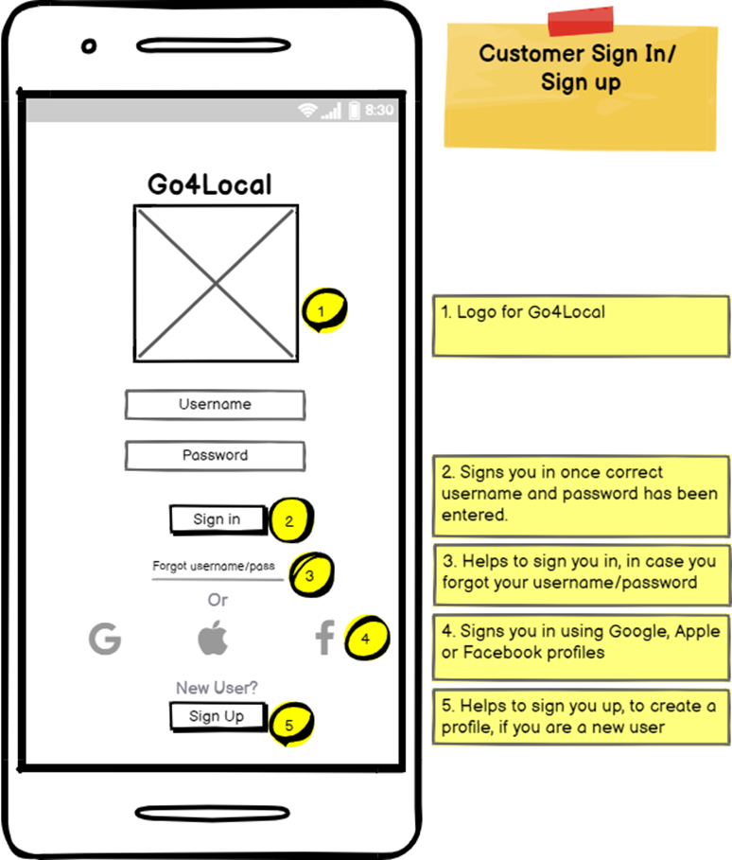

Aishwarya is a working professional, who is exhausted after coming from the office, she has a lot of grocery shopping to do. She came to know about this app from her friend and decided to give it a go. After installing the app, Aishwarya clicks “Sign up” as she is a first-time user, which leads her to the second page.

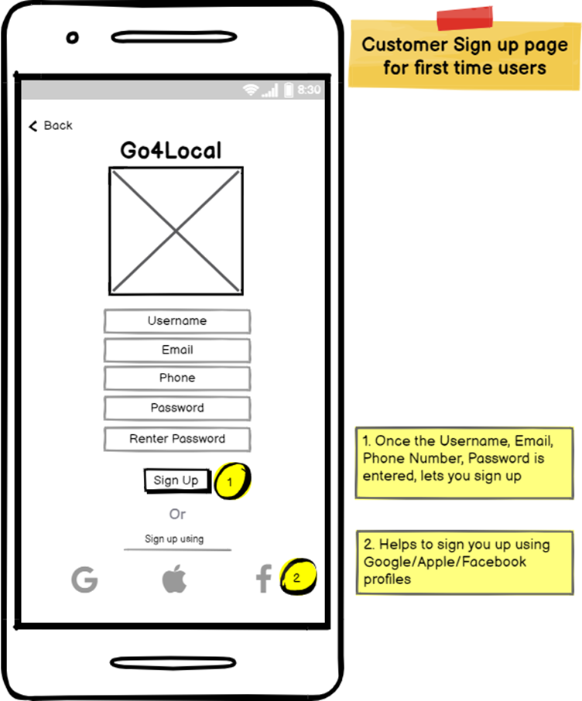

Aishwarya inputs her Name, Email address, Phone Number, Password and Signs Up for the app. She also realizes that she has an option to sign up using her Gmail/Apple/Facebook profiles but she chose to sign up using this way instead. After entering all the required details, she clicks sign up and it leads her to Page 3.

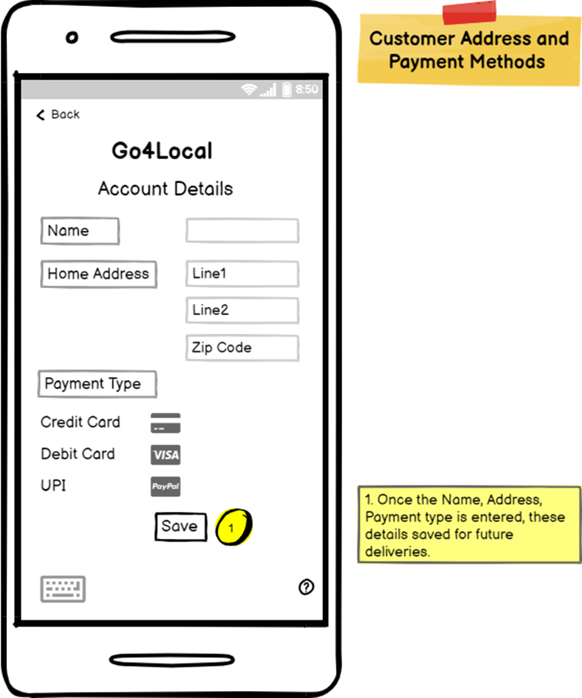

After clicking sign up, it takes her to “Customer Home Address and Payment Methods” page, where she has to enter the Her Home Address and Payment methods. Aishwarya enters her Home Address and Payment Type. And clicks on “Save”. And this takes her to the next page.

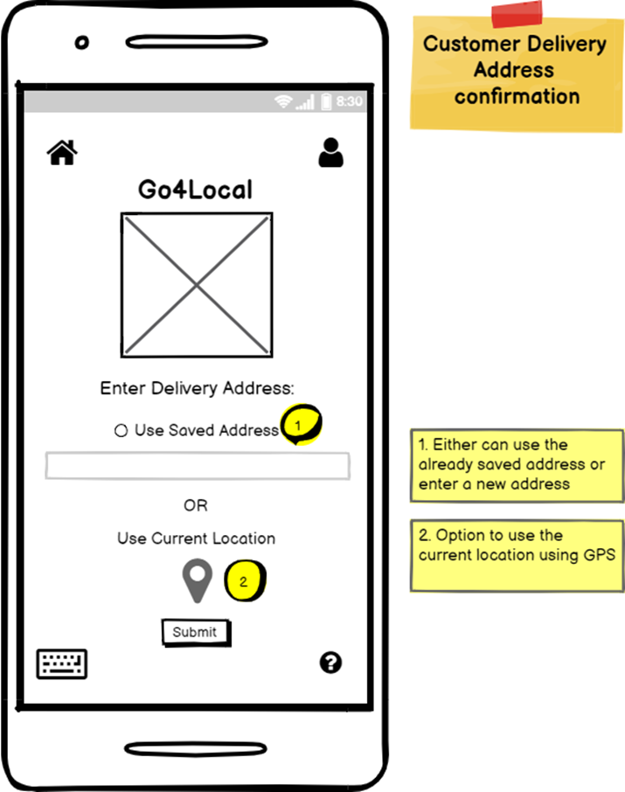

Now in this page, Aishwarya enters her delivery address for which she is doing the purchase order.

She realizes there is also an option to use her live location using GPS. Anyway, she enters the delivery address and clicks “Submit” which takes her to the next page.

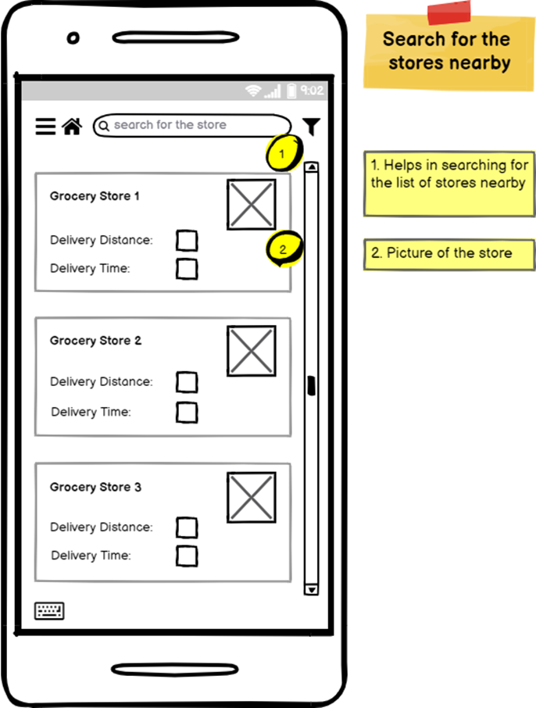

After clicking “Submit”, she is taken to the “Search for the stores nearby” page, where she can either search the stores by names or ZIP code. Aishwarya enters the ZIP Code, and the nearby stores are listed along with their Delivery Distance and Delivery Time taken. Then she clicks a store of her choice, and it takes her to the next page.

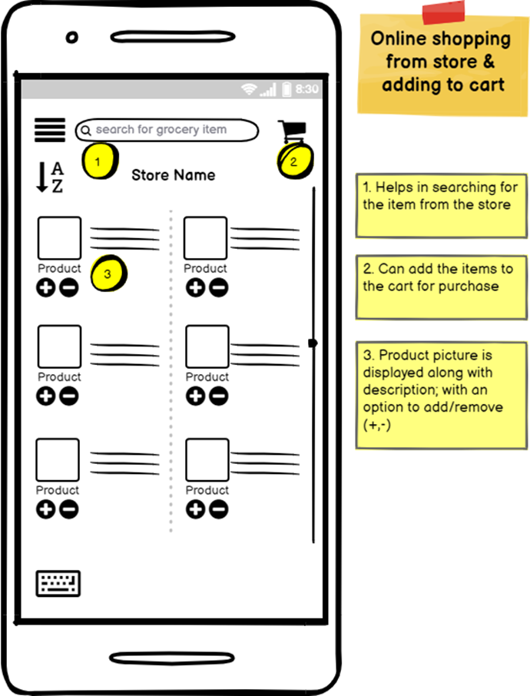

Once she clicks the store of her choice, then it takes her to the next page “Online shopping from store & Adding to the Cart”. Here she can search for a particular item and browse the product list from that store and add it to the cart. It also gives an option to add/remove the items according to her choice.

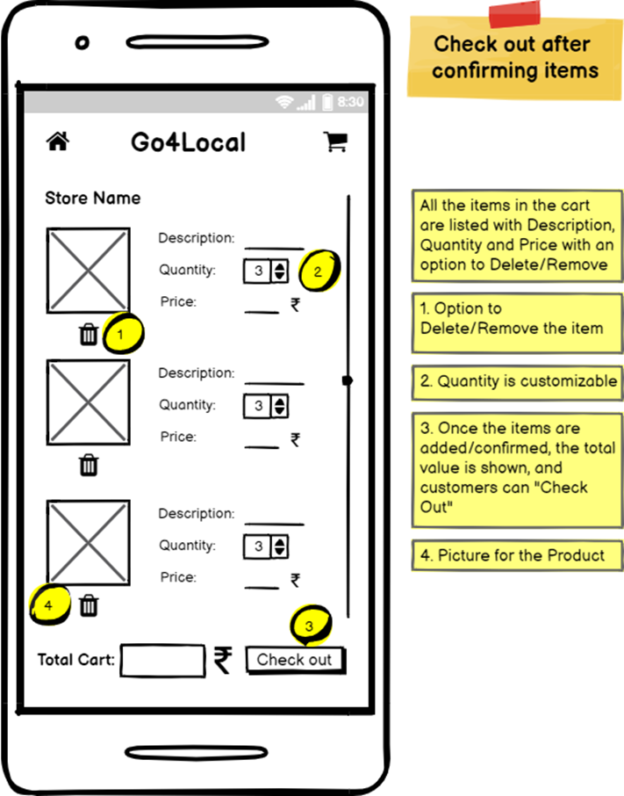

After she has added everything to her cart, then the app takes her to the check-out page.

Aishwarya removes the items which she doesn’t need and clicks the button “Check out” to confirm the order. This takes her to the next page which is Order confirmation.

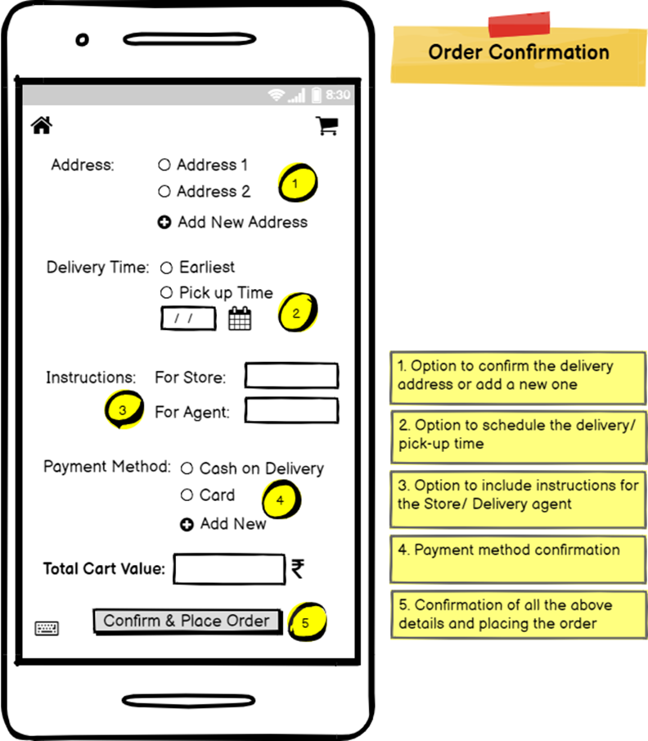

Once she clicks “Check Out”, the app leads her to the next page “Order confirmation”.

Aishwarya confirms her Address details, Delivery time: whether she needs it at the earliest or at a later convenient time. She also enters an instruction to the delivery agent asking him to “Hand over the package to the Security personnel at the Gate in front of the building”. She adds the payment method and then once she confirms all the detail is right, she clicks the button: “Confirm and Place Order”, which leads her to the next page.

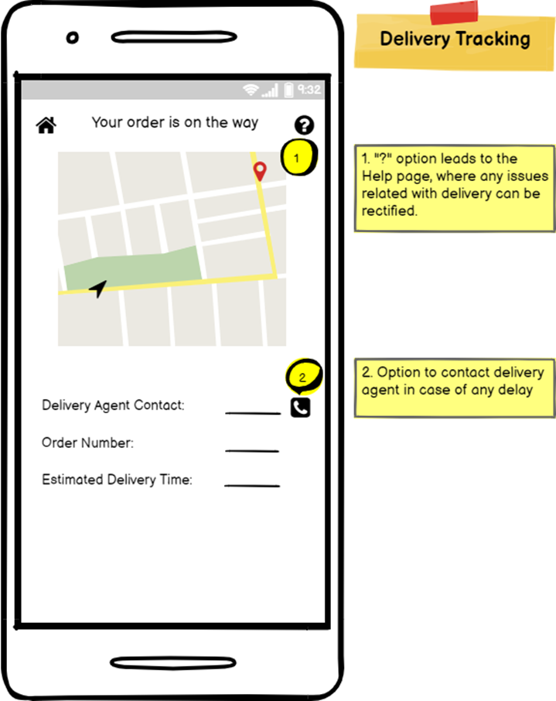

Once she clicks “Confirm & Place Order”, the app leads her to the next page which is tracking the order. Along with the details of Delivery agent, Order Number and the Estimated Delivery Time, she can see the status of her order

After some time Aishwarya realizes it has been 10 minutes and there is no progress from the current update. She needed to get it clarified and click on the “?” button towards the top right.

After clicking the “Help: “?” “button, it leads her to the next stage.

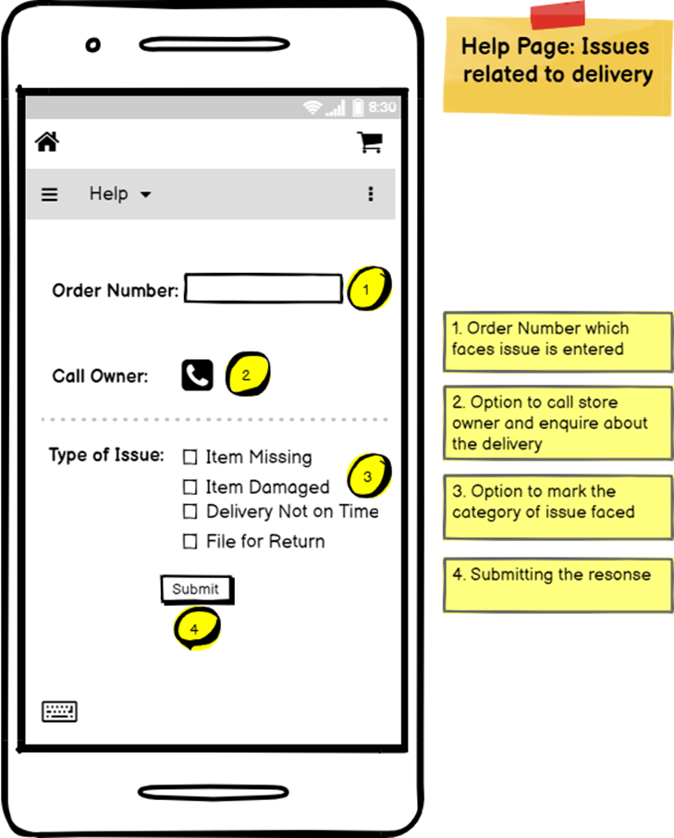

Now she enters her Order Number, submits the response about the type of issue she is facing, she also calls up the store owner to enquire about her purchase.

The support team gets in touch with her and ensures a faster delivery.

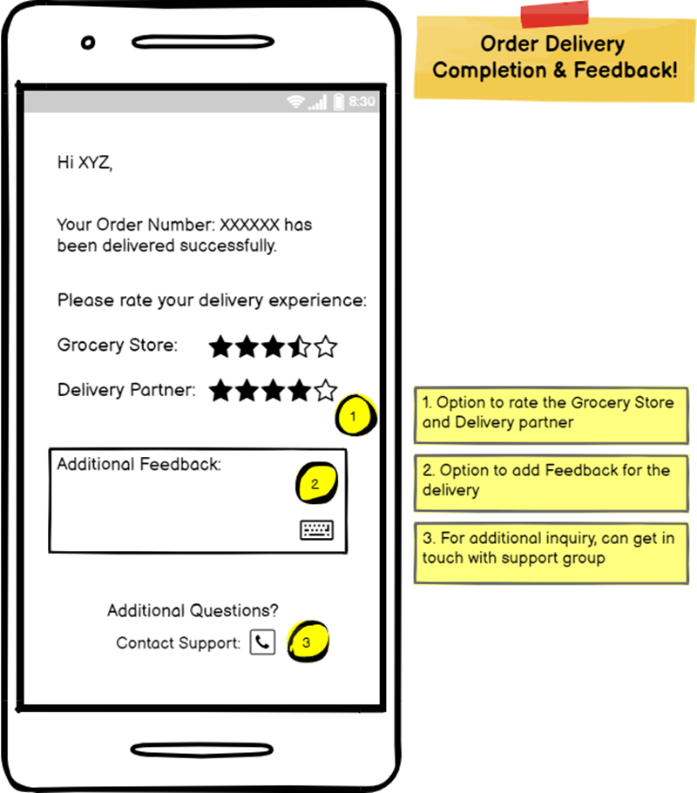

Once the response is submitted, the support group reaches out to her, and the delivery is expedited.

And finally, her order is delivered successfully.

Aishwarya receives a message saying her order has been delivered successfully. Aishwarya rates her delivery experience about the Grocery Store and Delivery Partner.

She also inputs her feedback about her whole experience.

## **Detailed Design & Features Description**

### Design Principles

1. User control & freedom – Users may add or delete products or make any mistake while ordering; give users the freedom to redo or undo by back & forward buttons.
2. Consistency & standards - Words & instructions follow a standard convention throughout the user journey.
3. Help & documentation – Users may need help at any stage of their order, customer support or help should be easily visible.
4. Aesthetic & minimalist design - Users should be able to focus on ordering products & not be distracted by unwanted, non-functional design elements.
5. Intuitive navigation – Users should be able to easily learn & navigate through the application without any explanations along the way.
6. Touch screen target sizes – Users navigate the app using fingers, thus targets on the should be big with enough spaces between to avoid undesired actions.

### Features

|  |  |  |  |
| --- | --- | --- | --- |
| **Feature** | **Detail** | **Dependencies** | **Priority** |
| Sign in/ Sign up | Signs in the user if correct username & password  Helps user sign in incase forgot username & password  Signs in users using Google, Apple ID, or Facebook SSOs  Sign up new user & create profile | Build backend to handle sign in & authentication process with respective APIs, for example, integrating Facebook SDK in Maven for SSO | High |
| New users sign up | User can sign up by creating a username, entering email & phone number, & creating a password.  User can also sign-up using Google, Apple, Facebook SSO | Use backend API like rest API to communicate between application & remote user database to create & fetch data from the database | High |
| Customer address & Payment methods | Users can add home/delivery address & payments methods for faster location identification & checkout | Integrate Google Pay API, BlobStorageManager API | High |
| Current Location to deliver/view stores | User can choose already stored address or enter new address  User can also use current location using GPS tracking | Integrate location APIs available in Google Play services facilitate adding location awareness with automated location tracking | High |
| View/ search stores | Stores are listed in descending order of distance  Users can view store name, store picture, delivery distance, & delivery time  Users can search for stores using search bar  Users can filter the stores based on different preferences  Users can scroll down to view other listings  Home button can be used to refresh the page  Sandwich menu to navigate to different sections of the app | Dependent on store owners to list products on the platform  Dependent on google map location services | High |
| Store product listing | Users can search products in the store  Users can add/remove products to/from cart for purchase with +/- buttons  Users can view product description | Get product/ data from external API | High |
| Cart to view added products | Users can view the product description, quantity, and price with option to delete from cart  Users can increase or decrease quantity  Total cart value is displayed at the bottom  Users can click on “check out” to go to the payment page | Get product/ data from external API | High |
| Check out page | Users can confirm address or add a new one  Users can schedule delivery or choose earliest delivery  Users can provide extra information to store owner and delivery agent  Users can confirm or add a new payment method  Users can confirm all the information and place order | Integrate Google Pay API, BlobStorageManager API  Use backend API like rest API to communicate between application & remote user database to create & fetch data from the database | High |
| Delivery Tracking | Users can view the live location of the order once it is picked up by the agent  Users can contact the delivery agent in case of any change in delivery instructions  Users can view live updates on estimated delivery time  Users can view order numbers for reference | Integrate Maps SDK for Android  Delivery person on time and with correct order | High |
| Help page | Users can report issues related to delivery & seek help from customer service  Users can contact the store to enquire about order issues  Users can select multiple categories of issues to report & submit | Building a great customer service team in limited budget  Dependent on store owner for correct & timely response | Medium |
| Feedback page | Users can view of summary of the order  Users can rate the store & the agent  Users can provide additional feedback on delivery in a text box  Users can contact customer service with additional help |  | Medium |

### 

### Minimum Viable Product (MVP)

Priority 0 – Critical features:

1. Sign up/sign in page
2. Customer profile & adding payment method
3. Selecting location to view the neighborhood stores
4. View/search stores
5. Product filtering
6. Viewing instore products listed
7. Cart to view added products
8. Check out page
9. Delivery tracking
10. Help page

### Priority 1:

1. Feedback page
2. Multi store delivery – to order products from multiple stores
3. Increase delivery radius to 3km

## **Roadmap / Timing**

**QUARTER 1:**

Initially we plan to launch the app to cater to our customers within every 1 km radius of the customer having at least 40 percent of the stores within their locality. This is targeted to onboard the customers onto our platform and application. We plan to have a sign-up page asking for the customer details and their location to place the item from their preferred grocery store with different payment options. This would also serve as the MVP of the product we would be launching. We aim to deliver the product to its customers within 3 hours of the customer placing the order and from the grocery store owner point of view, we aim to generate at least 500$ worth of orders through our application. Acquiring 20 percent of working professionals within a grocery store would be a key milestone for the team. The product which would be launched in this quarter would be our MVP. We will also set up a minimalistic customer feedback team who can handle calls from users of our application on ‘missing item’ and ‘damaged’ issues related to the delivery. Development and marketing team

**Customer Feedback**

**Delivery Throughput**

**Onboarding Platform Users**

**Themes**

**Customer Service**

**Goal:** Provide customer service through calls, on 2 order issues: missing and damaged

**Priority:** High

**Effort:** Medium

**Delivery Time**

**Goal:** Deliver products within 3hrs of placing the order from a single store within 2km

**Priority:** High

**Effort:** High

**Goals**

**Onboarding Grocery Stores**

|  |
| --- |
| **Goal:**  Onboard 25 essential grocery stores within every 1km radius, with every user having at least 40% of the stores within their locality on the platform |
| **Priority:** High  **Effort:** High |

**Store Weekly Sales**

**Goal:** Deliver $500 worth of groceries for each store per week

**Priority:** High

**Effort:** High

**Acquiring Customers**

**Goal**: Acquire 20% of the working professionals within a neighborhood of a store

**Priority:** High

**Effort:** High

**QUARTER 2:**

In quarter 2 launch, we will add 15 percent additional items to the list of grocery items that a user can order from our application. Team will lay down more stress and importance on onboarding 20 percent more working professionals. Application will offer the customers to order items and groceries from multiple store’ in their vicinity. Customer feedback and support team will focus on reducing product related issues by 20 percent.

**Themes**

**Onboarding Platform Users**

**Customer Feedback**

**Delivery Throughput**

**Goals**

**Multi Store Delivery**

**Goal:** Deliver products from multiple stores located within 0.5 km distance of each other

**Priority:** High

**Effort:** High

**Order Issues**

**Goal:** Reduce product related issues by 20%

**Priority:** High

**Effort:** Medium

**Products Listed**

|  |
| --- |
| **Goal:**  Increase avg number of products listed per store by 15% |
| **Priority:** High  **Effort:** High |

**Increasing Customers**

**Goal**: Increase number of working professional customers by 20%

**Priority:** Medium

**Effort:** High

**QUARTER 3:**

Quarter 3 launch of the application will involve expanding the service to different metropolitan cities in the country (New Delhi, Bangalore, and Ahmedabad). Team will concentrate on acquiring and on boarding 50 percent more grocery store owners compared to quarter 2. Team plans to launch a referral program to capture student segment of users to expand into different horizons to increase market presence and profit, increase the delivery distance of groceries to 3 kilometers. We will plan to deliver products to customers within 1.5 hours of placing the order from a single store which is within 3-kilometer radius. Team will strive to keep the average experience and feedback of customers to 3 stars and above out of 5.

**Themes**

**Onboarding Platform Users**

**Customer Feedback**

**Delivery Throughput**

**Goals**

**Delivery Experience**

**Goal:** Keep average delivery experience rating 3+ out of 5

**Priority:** Low

**Effort:** Medium

**Delivery Time**

**Goal:** Deliver products within 1.5hrs of placing the order from a single store within 3km

**Priority:** High

**Effort:** High

**Expansion**

|  |
| --- |
| **Goal:** Expand to 3 cities: New Delhi, Bangalore, Ahmedabad; on-board at least 50% stores compared to previous quarter |
| **Priority:** High  **Effort:** High |

**Delivery Distance**

**Goal:** Increase delivery distance to 3km

**Priority:** Medium

**Effort:** Medium

**Referral Program**

**Goal**: Launch referral program to capture 10% of the student segment overall

**Priority:** High

**Effort:** Medium

**QUARTER 4:**

During quarter 4, we will launch the feature of C2C delivery of items and commodities with a weight limit of maximum 4 kgs. This feature will be enabled by the development team to accommodate customers to pick up and drop off their items to others in the neighborhood. We aim to increase the number of students who would use our application by 20 percent from the previous quarter, the sales and marketing team will focus on acquiring more students onto our application. The development team will launch a beta program to test the quality and rating of individual items delivered. We plan to launch an extra feature to the customers to order medicines from their local pharmacy stores. The team will develop and launch a chat feature on the application to enable users to upload and verify their doctor’s prescription to be shared with the chemist. Product team will improvise on improving the average issue resolution time by 30 percent.

**Customer Feedback**

**Delivery Throughput**

**Onboarding Platform Users**

**Themes**

**Customer Service**

**Goal:** Improve issue resolution time by 20%

**Priority:** High

**Effort:** Medium

**Goals**

**C2C Delivery**

|  |
| --- |
| **Goal:** Launch C2C delivery service for 60% of neighborhoods with weight limit of 2kg |
| **Priority:** High  **Effort:** Medium |

**Product Rating**

**Goal:** Launch beta program for 30% of customers to rate individual products after being delivered

**Priority:** High

**Effort:** Low

### 

**Increasing Customers**

**Goal**: Increase number of student segment customers by 20%

**Priority:** Medium

**Effort:** High

**Chemist Chat Feature**

**Goal:** Launch a chat feature for all of customers to upload doctors’ prescription to share with chemist

**Priority:** Medium

**Effort:** Medium

### 

## **Metrics**

The core user actions for the product are:

1. Creation – List products on the application
2. Consumption – Buy products
3. Curation -

* Rate the shop
* Rate the product
* Report

Metrics that help track the health of the product:

1. Avg order value per buyer per month

1. Order frequency per buyer per month
2. Buyer retention rate
3. Avg order fulfillment time
4. Avg wait time for the store owner to have a delivery agent pickup order
5. Customer satisfaction score
6. Number of orders per hour
7. Monthly churn rate
8. Avg app session duration
9. Number of new grocery sellers registered per month
10. Revenue from repeated customers
11. Sales per store per month
12. Shipping error rate
13. Total number of product listings
14. Percentage of idle drivers per month

The company earns revenue every time a buyer orders grocery. Thus, the most important metric for this product is avg order value per buyer per month.

**Projected Costs**

**Cost calculation**

Total time needed for development= 4 months

Team of 5 engineers and 1 Product Manager

Machines/ computer systems= 6/ month

Storage system Amazon S3= $2400

Total Operational Cost= $800 x 5 engineers + $900 x 1 PM + $700 x 6 machines + $2400

= $11500/ month

= $138,000/ year

Assumptions:

* No. of pages to be developed= 30 pages
* Each engineer will develop 6 pages
* Monthly salary of an engineer is $800
* Monthly salary of a Product Manager is $900
* For infrastructure we are using Amazon Web Services AWS which costs $2400 per month

## **Operational Needs**

Team plans to develop a strong relationship with grocery store owners to facilitate delivery of groceries while simultaneously acquiring more users onto our platform.

At launch, we will hire a sales and marketing professional to talk and develop a rapport with the grocery store owner and to sell our idea or delivering groceries and how it could benefit their business.

Going forward, during quarter 2 and quarter 3, we will hire more customer support personnel to address customer issues and needs related to the application and delivery of groceries.

In quarter 4, we aim to launch Customer to Customer (C2C) delivery of items and commodities along with trying to increase the number of students who would be using our application. We will launch a beta program in this quarter to a certain percentage of customers who can rate the quality and service of individual items delivered. We will launch a chemist chat feature to all customers to facilitate them to upload their doctor’s prescription to be shared with chemist. Team aims to improve grievance resolution time by 20 percent.

**Development and Testing Team:**

* Handles the initial development of the application to be released as MVP along with quarterly updates as planned and documented.
* Testing team will handle the responsibly of testing the new products and features that are being added in each quarter.

**Design Team:**

* Design teams takes care of designing the UI/UX of the application to make sure the customer can find what he/she needs to increase customer retention.
* Design team will concentrate and work on increasing the look and feel of the application to make sure it is being timely updated to accommodate customer needs.

**Sales and Marketing Team:**

* Sales and Marketing Team takes care of on boarding grocery store owners in the neighborhood and selling the idea and benefits of our application to delivery executives to onboard them onto our platform for grocery delivery.
* Sales and Marketing Team takes care of advertising our platform to different audience and population categories to increase our service visibility.
* Sales and Marketing Team takes care of handling social media profiles like Facebook and Instagram to keep our social media presence in the market.

**Data Analytics Team:**

* Data Analytics team handles the responsibility of surveying the market and customers to understand customer needs and market trends to make sure our service does not lag behind in terms of what the customer desires.
* Data Analytics team surveys competitors to give feedback to the development team on how our platform and service can be improved to keep up with time and to keep ourselves ahead of the competitors and pitfalls.

## **Addressing Caveats/risks**

Consider presenting risks in table format with columns providing detailed descriptions and possible mitigants for each risk.

|  |  |  |
| --- | --- | --- |
| **Risk** | **Description** | **Mitigation Strategy** |
| Privacy Concern | Both buyers and sellers would have privacy concerns regarding who has access to their data, e.g.: transaction, debit/credit card information, etc. | We need to have a team of highly skilled professionals who work on secure data storage and encryption systems for all customer records. |
| Legal/Patent Risk | We need to make sure that we are not breaking any law. | A team of corporate lawyers for the company would be a great way to avoid any ignorance of the law. |
| Piracy Concern | Since there are a lot of competitors who are already there in the market it is easier for them to replicate the features. | Copyrights, patents, end-user agreements. Having an app product key. |
| Interdependencies with key internal systems/processes/operations | Need to make sure all the cross-functional teams are following the deadline, on the same page, and can reach the milestone on the agreed timeframe. | Hiring a Product Manager is a good start to making sure all the teams are on the same page and working within the agreed timeframe. |
| Availability of required 3rd- party complements | Collaborating with any 3rd party complements can pose a threat for credential theft and data exfiltration. | Having a solid team that would work towards secure data storage and encryption systems. |
| Cash Flow | Falling short or stagnation of cash flow for the development of features of the product. | 1. Conduct a prior predictive analysis of cash flow. 2. To raise funds through other sources. 3. Keeping operational costs low by optimizing processes. 4. To keep a buffer amount for future development of the product. |

Group Members:

1. Ashutosh Vishwakarma; [vishwakarma.a@northeastern.edu](mailto:vishwakarma.a@northeastern.edu)
2. Rochana Devidas Dudwadkar; [dudwadkar.r@northeastern.edu](mailto:dudwadkar.r@northeastern.edu)
3. Prateek Revadi; [revadi.p@northeastern.edu](mailto:revadi.p@northeastern.edu)
4. Krishna Unnikrishnan; [unnikrishnan.k@northeastern.edu](mailto:unnikrishnan.k@northeastern.edu)